Design Patterns in Software Engineering
A design pattern is a reusable, proven solution to a common software design problem. It is not a complete program; rather, it provides a general design structure that developers can adapt to their applications.
Design patterns are commonly classified into three main categories:
- Creational Patterns – concerned with object creation.
- Structural Patterns – concerned with how classes and objects are organized.
- Behavioral Patterns – concerned with communication and responsibilities between objects.

1. Creational Design Patterns
Creational patterns deal with how objects are created.
They make object creation flexible and reduce direct dependency on specific classes.

Common examples:
- Factory Method
- Abstract Factory
- Singleton
- Builder
- Prototype

Factory Method
The Factory Method provides a method for creating objects without requiring the client to directly create a specific class.

Room Rent Example
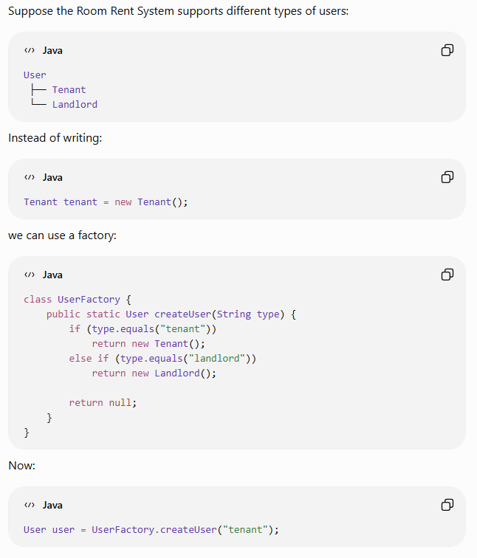

Benefit
- Reduces direct dependency on concrete classes.
- Centralizes object creation.
- Makes the system easier to extend.

2. Structural Design Patterns
Structural patterns explain how classes and objects are combined to form larger structures.

Common examples:
- Adapter
- Bridge
- Composite
- Decorator
- Facade

Adapter Pattern
The Adapter Pattern allows two incompatible interfaces to work together.

Room Rent Example
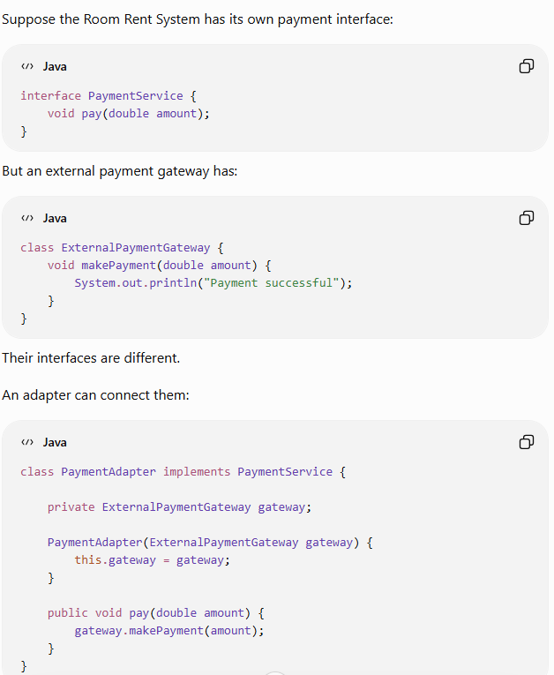
Now the Room Rent System can use the external payment system without changing its existing interface.

Benefit
- Connects incompatible components.
- Useful for integrating legacy or third-party systems.
- Reduces changes to existing code.

Composite Pattern
The Composite Pattern represents objects in a tree-like structure, allowing individual objects and groups of objects to be treated uniformly.

Room Rent Example
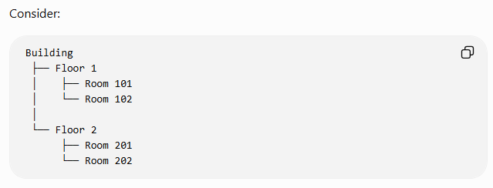
The system can treat a single room, floor, or building as part of the same hierarchical structure.

Benefit
- Useful for part-whole relationships.
- Simplifies handling of groups of objects.

3. Behavioral Design Patterns
Behavioral patterns focus on how objects communicate and how responsibilities are distributed.

Common examples:
- Strategy
- Command
- Observer
- State
- Template Method

Strategy Pattern
The Strategy Pattern defines a family of algorithms and allows them to be changed or selected independently.

Room Rent Example
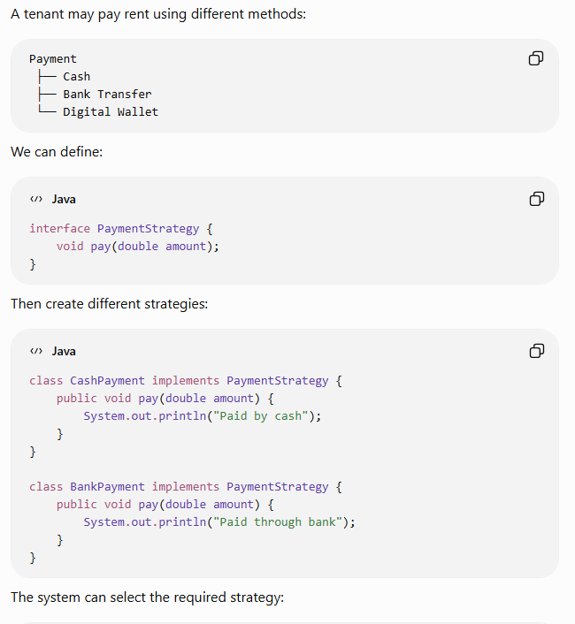
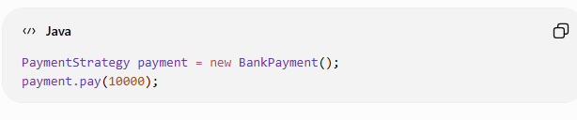

Benefit
- Makes algorithms interchangeable.
- Avoids large if-else statements.
- Makes the system easier to extend.

4. Command Pattern
The Command Pattern encapsulates a request or operation as an object.

Room Rent Example
Suppose the administrator can perform:
- Add Room
- Remove Room
- Allocate Room
- Collect Rent
Each operation can be represented as a command.
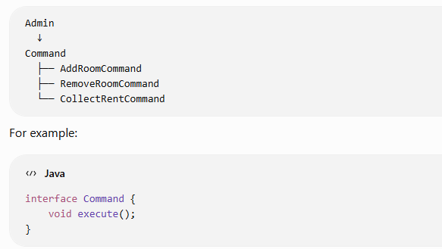
A command can then execute a particular operation.

Benefit
- Separates the request from the object that performs it.
- Supports logging of operations.
- Can support undo operations.
- Useful when operations need to be queued or scheduled.

Easy Comparison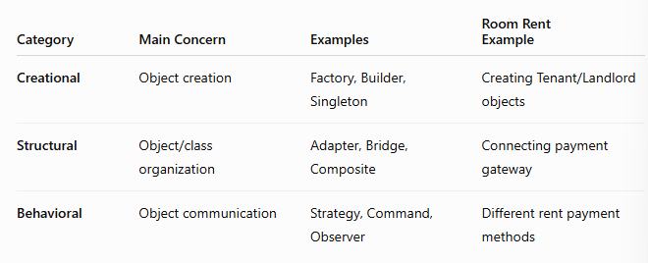

Easy Way to Remember

Creational → "HOW TO CREATE?"
Factory → creates objects.

Structural → "HOW TO CONNECT?"
Adapter → connects incompatible classes.

Behavioral → "HOW TO BEHAVE/COMMUNICATE?"
Strategy → changes payment method.

Exam Conclusion
Design patterns provide reusable and proven solutions to recurring software design problems. Creational patterns manage object creation, structural patterns organize relationships among classes and objects, and behavioral patterns manage communication and responsibilities. In a Java-based Room Rent Management System, Factory can create users, Adapter can integrate external payment gateways, Strategy can support different payment methods, and Command can represent administrative operations. Thus, design patterns improve reusability, flexibility, maintainability, and scalability of software systems.

